.Name: |  | _______________________________________________ |  |  |  | Date: _________
 |  | Year 10  60  = %  Mathematics  Test 7, 2015  Topics – Probability
Total Time: |  | 60 minutes
Total Reading: |  | 2 minutes
Total Working: |  | 62 minutes
CALCULATOR FREE
Time: | 10 minutes |  | Marks for Section: |  | 10
 |  |  | Equipment Allowed: |  | ½ page notes (A4 one side), Scientific calculator

1. [2 marks: 1, 1]
A bag contains 30 balls. 8 are pink, 6 are blue and the rest are white. If one ball is chosen at random from bag, find the probability that it is:
a) | White b) Pink or white
- [1 mark]
If the probability of an event occurring is 0.35, what is the probability of it not occurring?

3. [1 mark]
There are 120 teachers at a maths conference. If one of these is chosen at random the probability that they are a Year Ten teacher is . How many of the teachers are Year Ten teachers?

4. [2 marks: 1, 1]
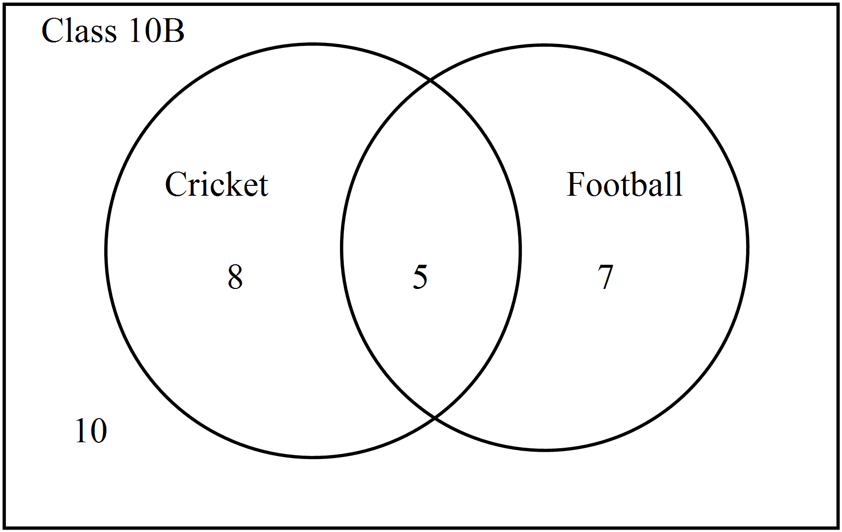The Venn diagram shown below shows the numbers of students in Class 10B who played cricket and football.

a) A student from Class 10B is chosen at random. What is the probability that the student plays both football and cricket?

b) A student from Class 10B is chosen at random. What is the probability that the student does not play cricket?

5. [4 marks: 1, 1, 2]
A single element is chosen at random from the set S: S = {b, c, d, 17, 19, 26, 29, *, §}
What is the probability that it will be:

- An asterisk?

- Neither a letter or a number?

- Would there be a greater chance of it being a number or a letter? Support your answer by calculating probabilities.

~ END OF SECTION ONE ~
CALCULATOR ASSUMED
Time: | 52 minutes | Marks for Section: | 50
Reading: | 2 minutes | Equipment Allowed: | ½ page notes (A4 one side), Scientific calculator
Working: | 50 minutes

6. [2 marks: 1, 1]
In the Venn diagrams below, shade the region stated:
a) b)

7. [5 marks: 3, 2]
Given that U = {1, 2, 3, 4, 5, 6, 7, 8, 9, 10},

A = factors of 10,
B = even numbers and
C = multiple of 3.

a) List the elements in the sets below:

A =

B =

C =

b) i) Find n(A ∪ B) ii) List B ∩ C

8. [6 marks: 2, 1, 1, 1, 1]
A sample of 120 students are asked if they eat breakfast in the mornings.
The results are shown in the table.

 | Male | Female | Total
Eat Breakfast | 24
Don’t eat breakfast |  | 37
Total | 52

- Complete the missing information in the table.

- A person is chosen at random from the sample, what is the probability that they eat breakfast?

- What is the probability that a person chosen at random is a female who eats breakfast?

- If a person who prefers to eat breakfast is chosen at random. What is the probability that they are male?

- A male is chosen at random. What is the probability that he does not eat breakfast?

9. [5 marks: 2, 1, 2]
- Draw a tree diagram to represent the possible outcomes for a couple if they choose to have three children.

b) Are these events independent?

c) Use the diagram to determine the probability that the couple will have:

i) Three girls.

ii) Two boys and a girl in any order.

10. [5 marks: 1, 1, 1, 1, 1]
The contents of 100 boxes of smarties were counted and the results recorded.

Number of smarties | 18 | 19 | 20 | 21 | 22 | 23 | 24 | 25
Number of boxes | 9 | 13 | x | 18 | 20 | 15 | 6 | 3

- Find the value for ‘x’ in the above table.

- What is the probability that a box chosen at random will contain exactly 22 smarties?

- What is the probability that any given box will contain more than 22 smarties?

- “It is almost certain that a box will contain less than 25 smarties.’ Is this statement true or false. Give evidence for your answer.

- If there were 400 boxes of smarties how many of these boxes would you expect to contain less than 20 smarties?

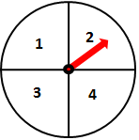
11. [3 marks: 1, 1, 1]
The spinner on the right is spun and a coin is tossed.
a) Draw a two way table to represent the sample space.

b) Determine the probability of obtaining a Head and a 4.

c) Determine the probability of obtaining a Tail or an even number.

12. [4 marks: 2, 1, 1]
An eight-sided die (numbered 1-8) is rolled.
A={numbers less than 4}
B={numbers that are multiples of 2}
a) Draw a Venn diagram to represent the above information.

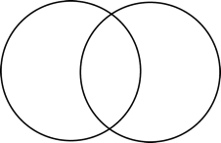

b) Calculate the probability that the number is less than 4, given that it is a multiple of 2.

c) Determine the probability that the number is a multiple of 2, given it is less than 4.

13. [5 marks: 2, 1, 1, 1]
Miss Christie surveys her class about what chocolate they like. Out of 30 students, 16 students like dark chocolate, 22 students like milk chocolate and 4 students like neither milk nor dark chocolate.
a) Draw a Venn diagram to represent the above information.



b) Determine the probability that a randomly selected student like both milk and dark chocolate.

c) Determine the probability that a randomly selected student likes milk chocolate only.

d) Given a student likes dark chocolate, what is the probability they like milk chocolate.

14. [3 marks: 1, 1, 1]
For each pair of events when rolling a regular die, decide if they are mutually exclusive or not.
Pair of events: | Mutually Exclusive
a) Rolling a number less than 3 and rolling a 6 | Yes or No
b) Rolling an even number and rolling a number greater than 4 | Yes or No
c) Rolling an odd number and rolling an even number | Yes or No

15. [7 marks: 3, 1, 1, 1, 1]
A bag contains 24 lollies: 10 are red, 6 are black and 8 are yellow. I eat two lollies from the bag.
a) Create a probability tree diagram showing all the possible outcomes

b) Find the probability they are both black

c) Find the probability the first is red and the second is black

d) Find the probability that given the second one is black, the first one is red

e) Find the probability neither of them is red

16. [5 marks: 1, 1, 1, 1, 1]
Using set notation:
If = 0.8, = 0.7 and = 0.4
a) Find

If = 0.4, = 0.3 and = 0.6
b) Find

If = 0.55, = 0.4 and = 0.1
c) Find d)

If = , and
e) Are events A and B independent? Explain your answer.

~ END OF TEST ~

